**GREENDALE SECONDARY SCHOOL**

**Subject Combination Option User Guide for Students (NA/NT)**

**URL: https://greendale.schoolhub.sg**

## Log in

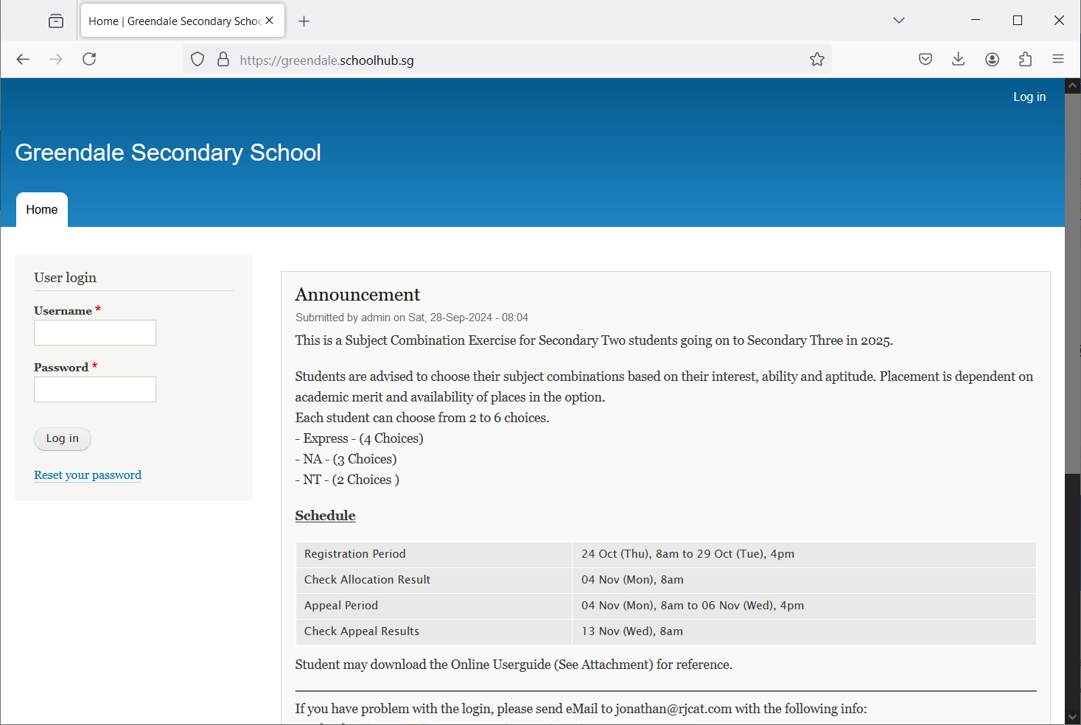

Steps

* Enter Username
* Enter Password
* Click on Log in button

## Main Menu

Upon Successful login, you will see the main menu

Update your Account

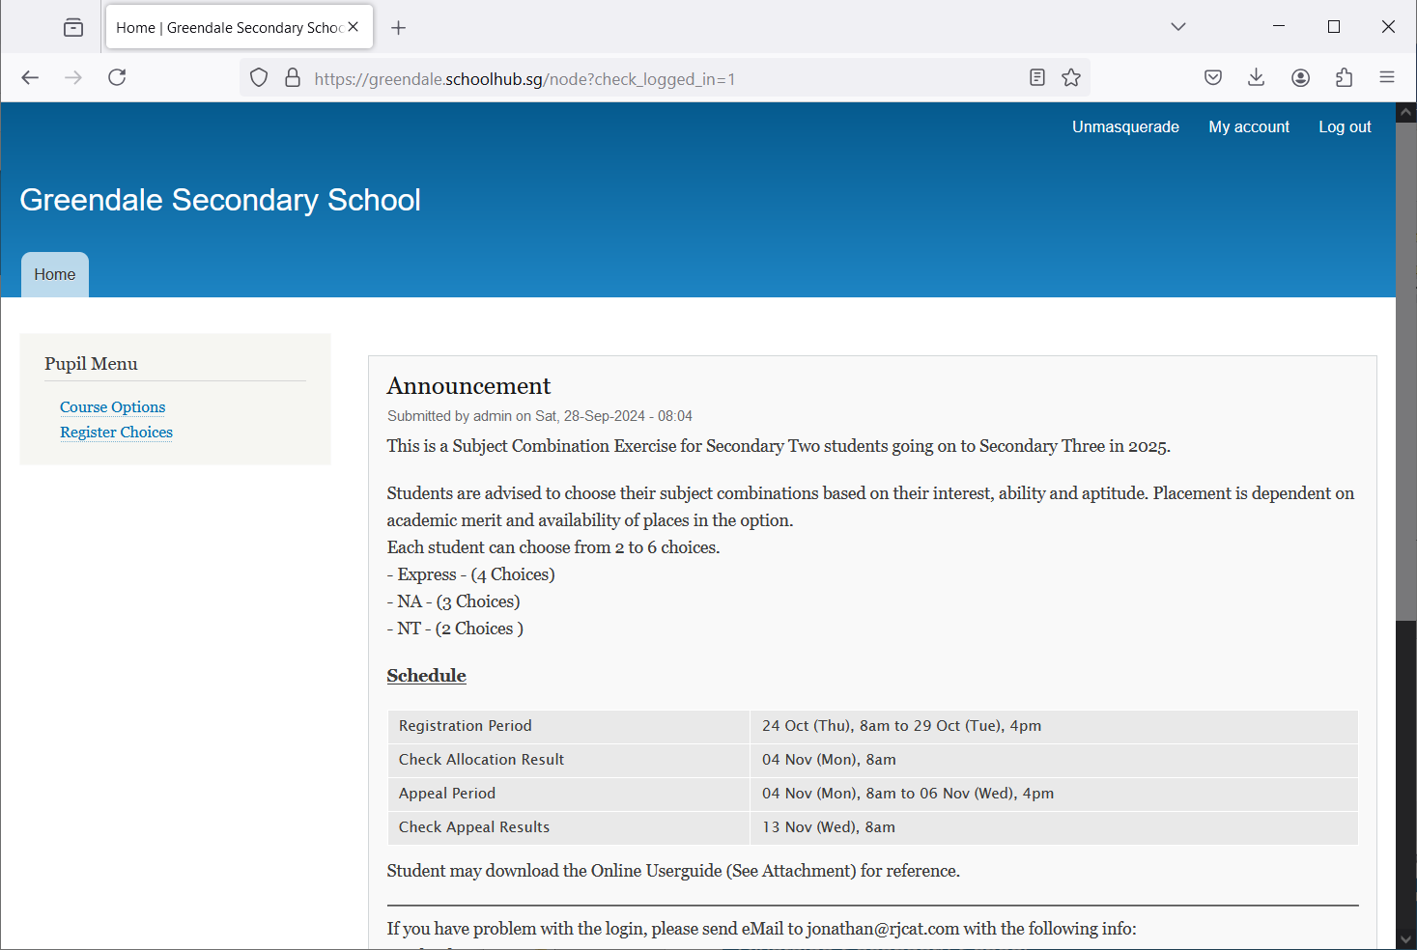

All Announcements will be posted here.

Update your choices

View all Subject Combinations

Send eMail if you have issue

## Update User Account

This is Optional. You may change your password and update your eMail before you proceed to your Subject Combination choices.

Click My Account

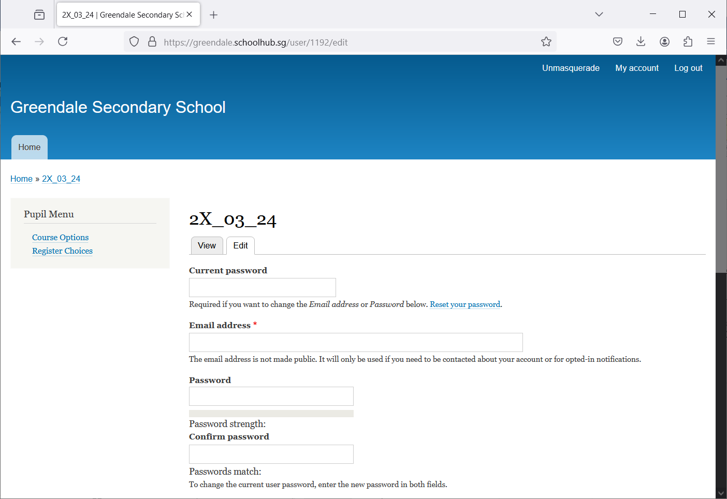

Steps

* Enter current password
* Update eMail Address
* Enter New Password (leave blank if you want to retain current password)
* Click on Save button

## View Course Options

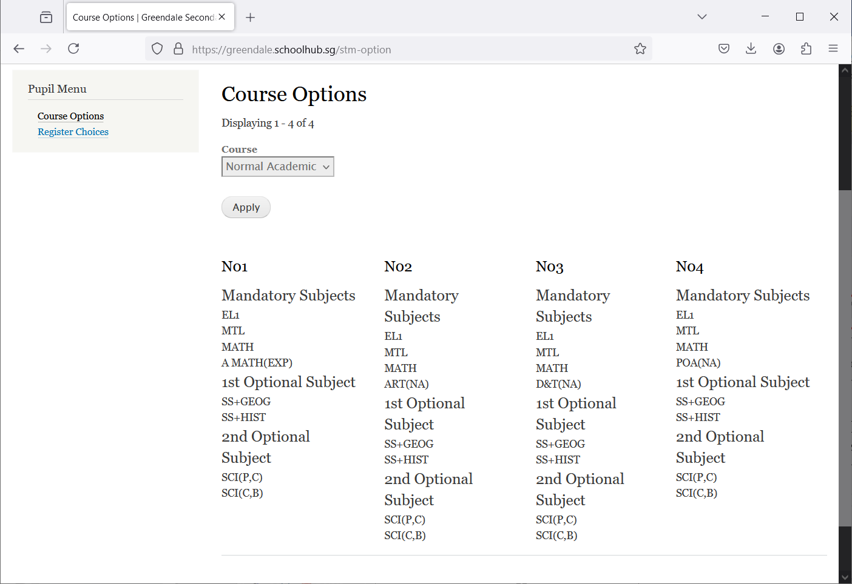

Click Course Options

## Registration of Choices

These are the list of Options you may choose from

Register your choices

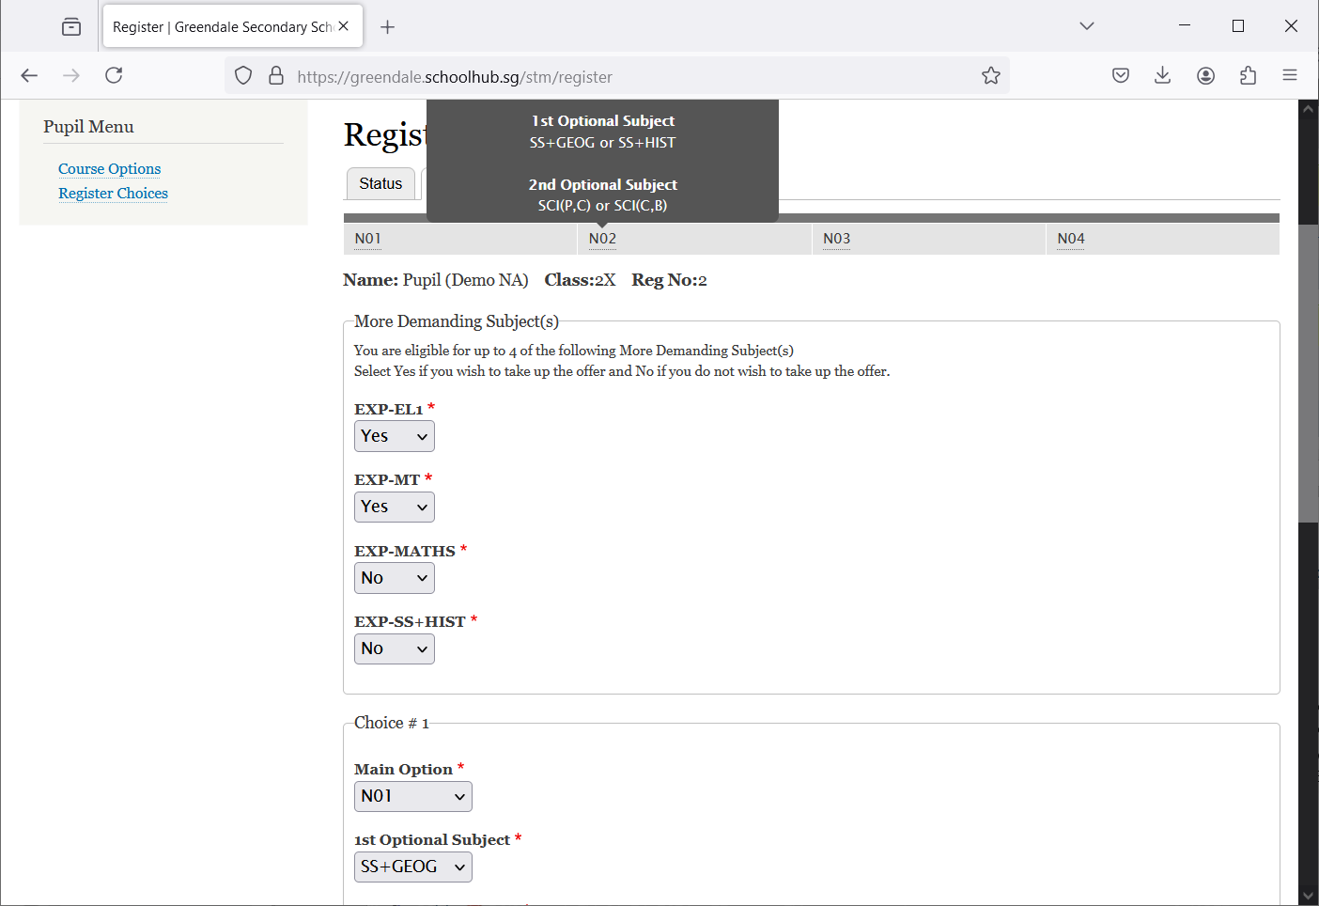

Indicate if you wish to take up the offer of OOS Subject

Mouse-Over to view the Subjects in the Option

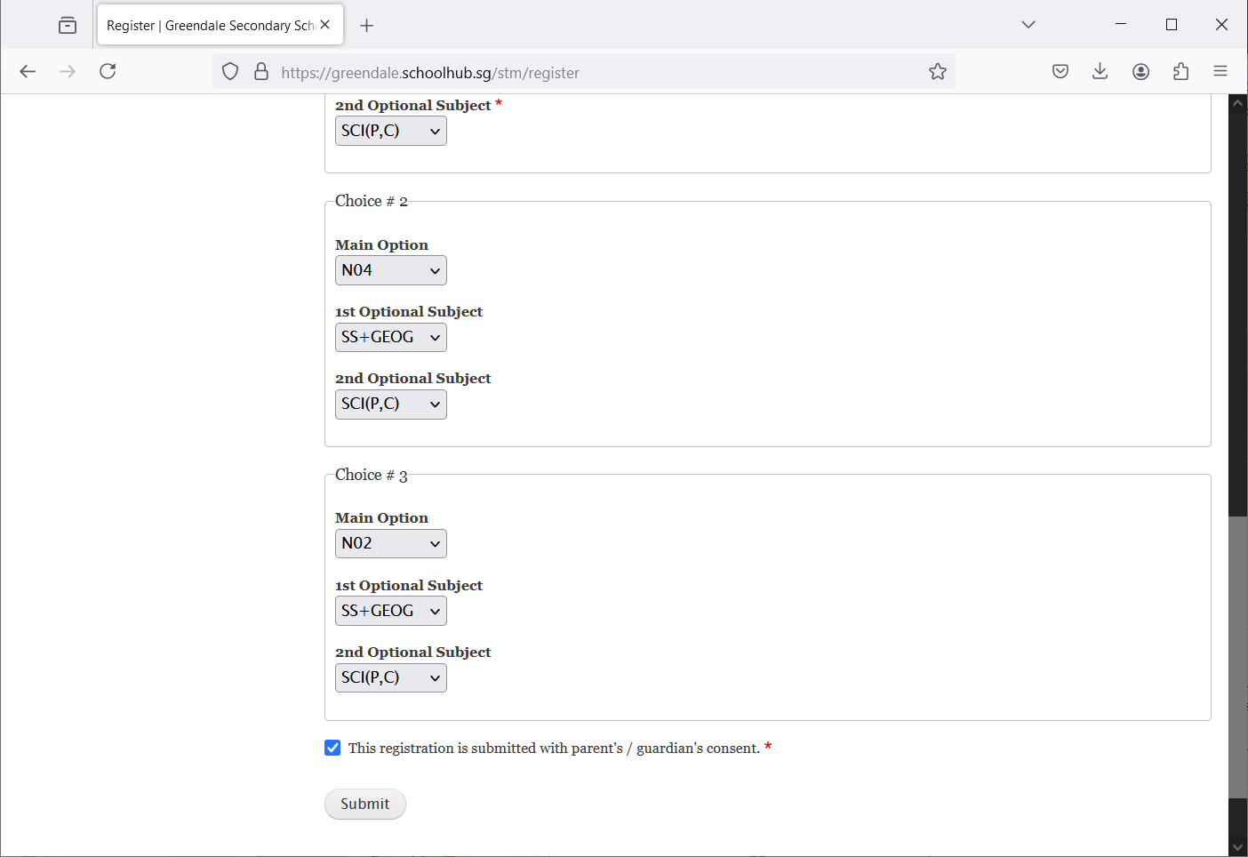

Tick this box

Steps

* Click on Student Option
* Update Your choices
* Click Submit at end of screen

Note:

You may change your choices any time before the closing date.

## 

## Print Confirmation Slip

Once you have Submit Successfully, you may proceed to Print the Confirmation Slip.

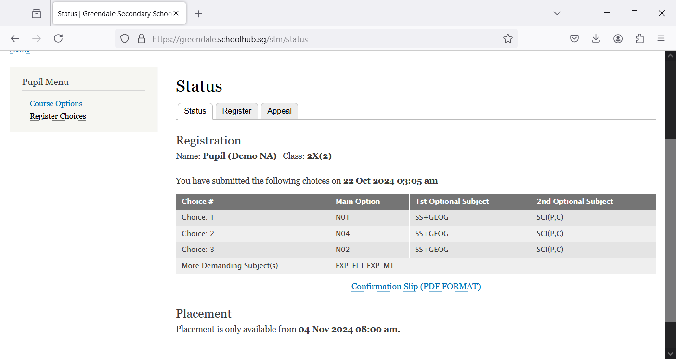

Print Confirmation Slip

Steps

* Click on Print Confirmation Slip (PDF Format)
* The hard copy confirmation slip must be signed and filled in with a contact number before submitting to General Office

**Sample Confirmation Slip**

